#### Supplementary Material

#### Disconnected Gas Transport in Steady-State Three-Phase Flow

Abdulla Alhosania*, Ahmed Selema, Qingyang Lina, Branko Bijeljica, Martin J. Blunta,b

*aImperial College London, Department of Earth Science and Engineering, London, UK*

*bDepartment of Energy, Politecnico di Milano, Italy*

* *Correspondence (1)*: [Abdulla.alhosani17@imperial.ac.uk](mailto:Abdulla.alhosani17@imperial.ac.uk)

* *Correspondence (2)*: [Q.lin11@imperial.ac.uk](mailto:Q.lin11@imperial.ac.uk)

#### 

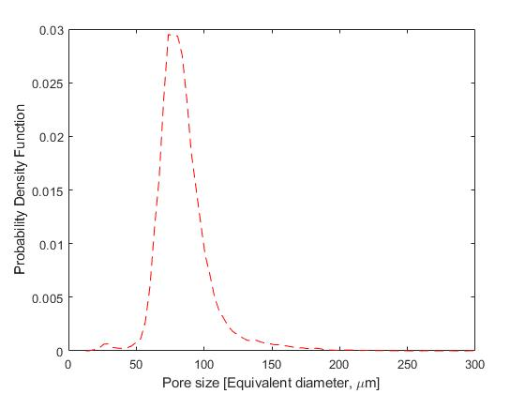

Figure S1. Probability density function of the pore size distribution in the Bentheimer sample used in the steady-state three-phase experiment.

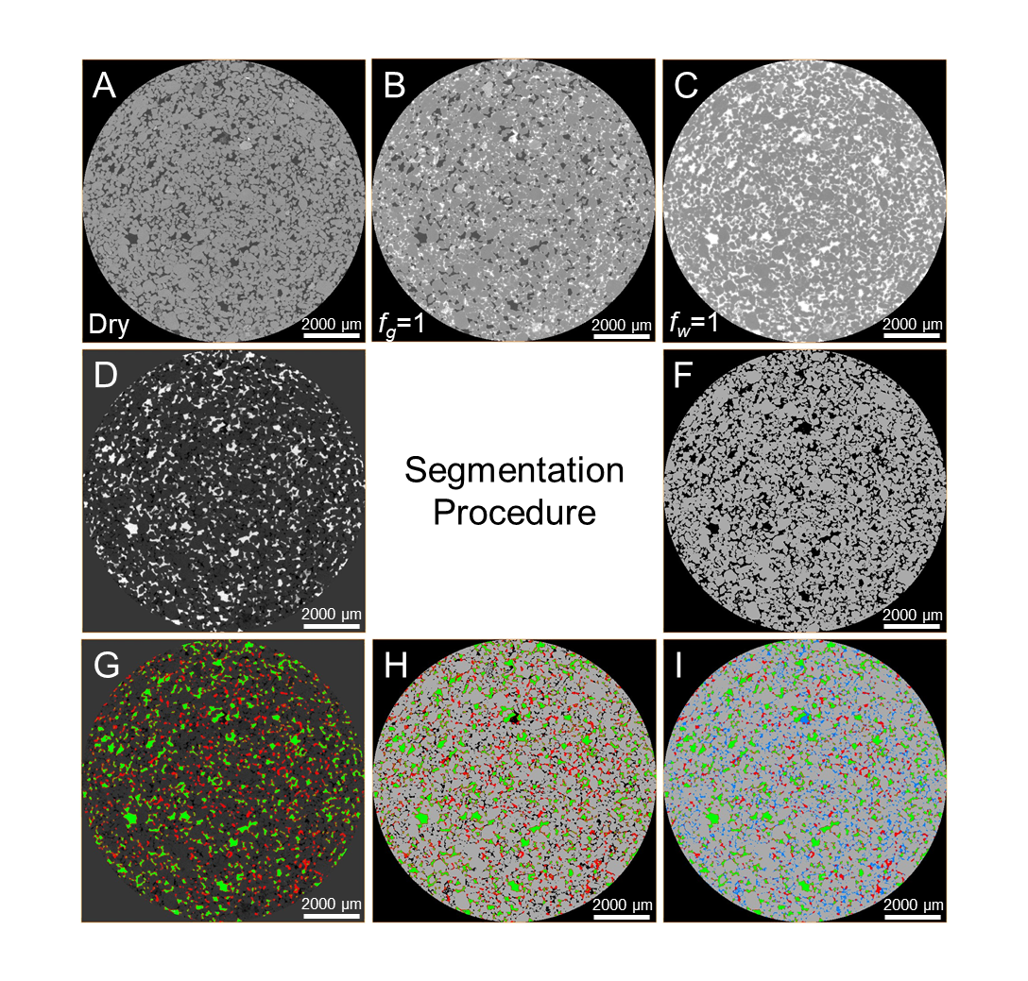

Figure S2. Image segmentation workflow. (a) A 5.3 µm/voxel raw cross-sectional image of the dry scan used to segment the rock phase directly with the interactive thresholding technique as shown in (f). To segment the three-phase scan, in (b), it was first subtracted from the water saturated scan, in (c), to clearly distinguish the oil and gas phases, as shown in light grey and white respectively in (d). The oil and gas phases in (d) were then segmented with the interactive thresholding technique, as shown in (g); using direct thresholding allowed us to assign the intermittent phases, with intermediate grey-scale values, to the phase, either oil or gas, with the closest grey-scale value. The segmented rock phase in (f) was then added to the segmented oil and gas phases in (g) as shown in (h). The unassigned voxels in (h) were then added as the water phase giving the final segmented three-phase image in (i).

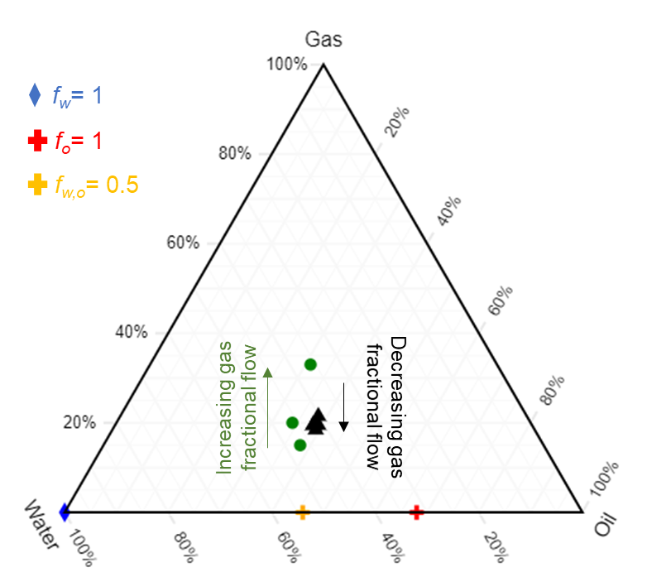

Figure S3. A ternary diagram showing the averaged saturations at each fractional flow in the steady-state three-phase experiment.

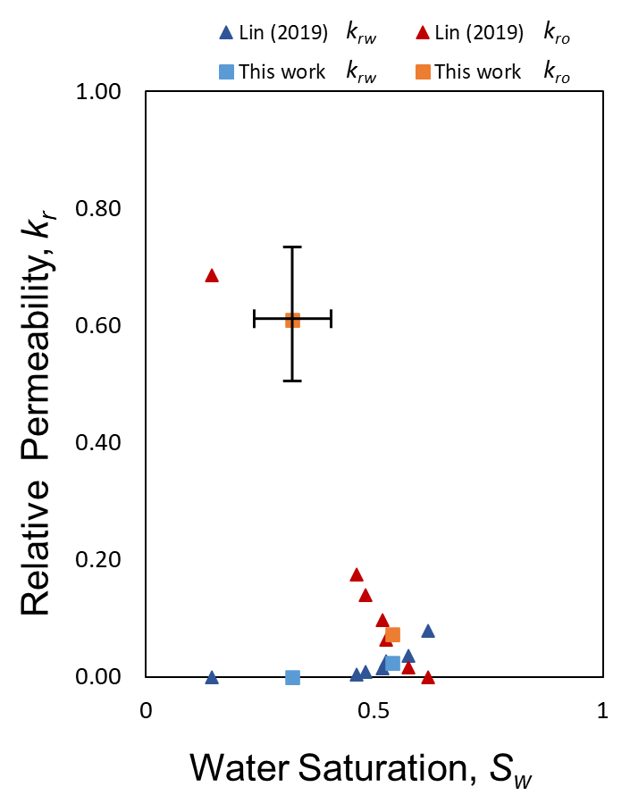

Figure S4. Two-phase water and oil relative permeability measured before gas injection in the steady-state experiment. The relative permeabilities are compared with the measurements of Lin et al. (2019). The error bar indicates the uncertainty in the measurements.

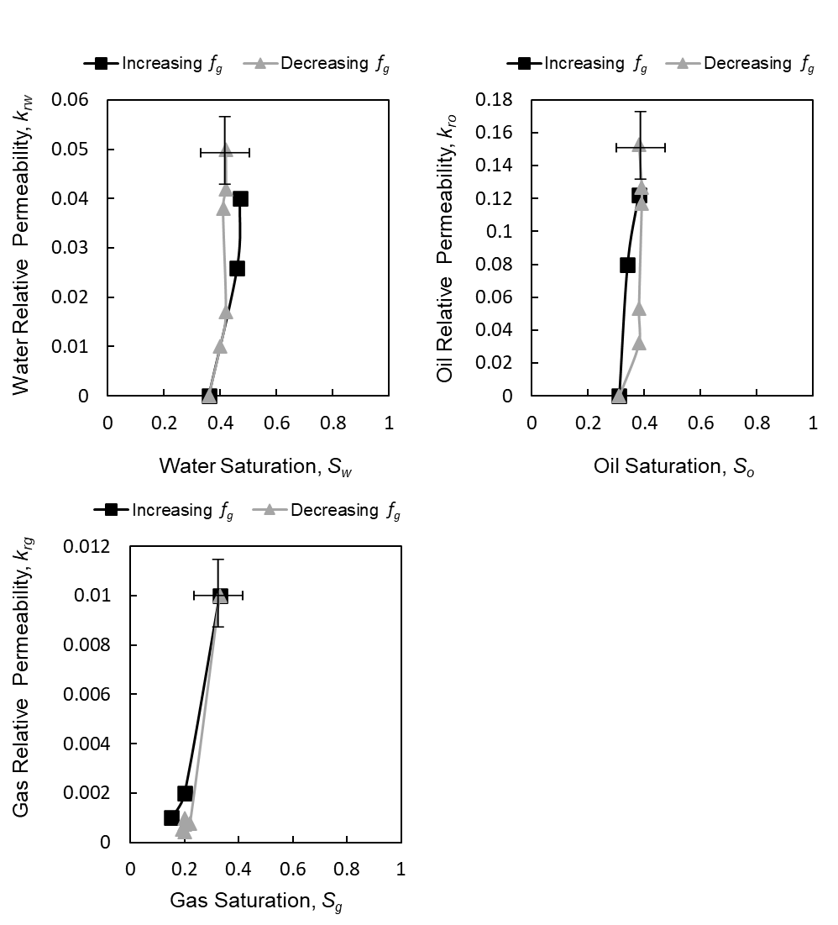

Figure S5. Steady-state three-phase relative permeability of (a) water, (b) oil, and (c) gas measured during increasing gas fractional flow – decreasing oil and water fractional flows – and decreasing gas fractional flow – increasing oil and water. Error bars indicate the uncertainty in the measurements.

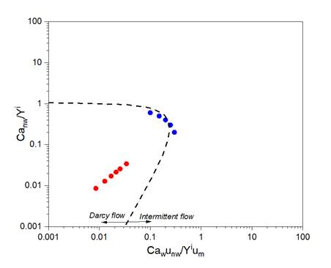

Figure S6. The phase diagram of the transition from Darcy regime to the viscous regime for the two fluid pairs, oil and water (red) and gas and oil (blue), used in the experiment plotted as a function of the non-wetting phase capillary number (*Canw*), gas in the case of gas and oil and oil in the case of oil and water, wetting phase capillary number (*Caw*), non-wetting phase viscosity (unw), wetting viscosity (um), and Y number (Yi) (Zhang et al., 2021).

# References

LIN, Q., BIJELJIC, B., BERG, S., PINI, R., BLUNT, M. J. & KREVOR, S. 2019. Minimal surfaces in porous media: Pore-scale imaging of multiphase flow in an altered-wettability Bentheimer sandstone. *Physical Review E,* 99**,** 063105.

ZHANG, Y., BIJELJIC, B., GAO, Y., LIN, Q. & BLUNT, M. J. 2021. Quantification of Nonlinear Multiphase Flow in Porous Media. *Geophysical Research Letters,* 48**,** e2020GL090477.